
Sreenidhi Institute of Science and Technology
Regulations:
A12
(An Autonomous Institution)
Code No: 3AC07 Date:9-Dec-16(FN)
B. TECH. IV-Year I-Semester Examinations, Nov/Dec 2016 (Supplementary)
CONTROL SYSTEMS (ECM)

Time: 3 Hours Max. Marks: 70
Note: a) No additional answer sheets will be provided.
b) All sub-parts of a question must be answered at one place only, otherwise it will not be valued.
c) Assume any missing data

Part - A
Max.Marks:20

Answer all QUESTIONS. EACH QUESTION CARRIES 2 MARKS.
1) Explain about SISO & MIMO control systems.
2) Why is a PID controller superior to PI & PD controllers? Draw suitable graphs to justify your answer.
3) How is stability of a system related to location of poles in‘s’ plane?
4) Mention the limitations of Bode plots?
5) In minimum phase system, how the start and end of Polar plot are identified?
6) Define state variables.
7) Write the transfer function of P, PI, PD and PID controllers.
8) Write in brief about the need for compensation.
9) From the Bode plots of a unity feed back system, 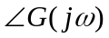 at gain cross over frequency is found to be -150 º & |G(jω)| at phase cross over freq is found to be -12 dBs. Find the stability of the system.
10) Write about the concept of controllability in brief.

Part – B
Max.Marks:50

ANSWER ANY FIVE QUESTIONS. EACH QUESTION CARRIES 10 MARKS.

1. a) By bringing out the concept of feed back, differentiate between open loop & a closed loop control systems. [4 M]
b) With the help of a neat block diagram explain the transfer function model of a DC Servomotor. [6 M]

2. a) Derive an expression for the steady state error of a 2nd order control system excited by a ramp input. How is it different from that of a system excited by a step input? [4 M]
b) Measurements conducted on a servomechanism show the system response to be
c(t) = 1 + 0.2 e^{-60t} – 1.2 e^{-10t}
when subjected to a unit step input.
(i) Obtain the expression for the closed loop transfer function.
(ii) Determine the undamped natural frequency & damping ratio of the system.
[6 M]

3. a) Explain the concept of stability using Routh Hurwitz criteria.
b) Explain the effect of adding poles and zeros to G(s)H(s) on the root loci.

4 a) Write the advantages of Bode plots. [3M]
b) Sketch the Bode plot of G(S) = 75(1+0.2S)/{S(S²+16S+100)} and determine phase
margin and gain margin. [7M]

5 a) Derive the transfer function of lead network. [4M]
b) The open loop transfer function of a unity feedback system is given by
G(S) = 1/{S(1+S)(1+2S)}. Sketch the Polar plot and determine gain margin and
phase margin. [6M]

6 a) Obtain state transition matrix for the system
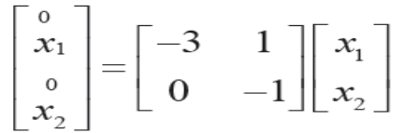
b) Obtain the state model of the system whose transfer function is given as,
Y(S)/V(S)=10/(S³+4S²+2S+1).

7. With the help of Nyquist plot assess the stability of a system 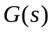 = 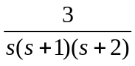
What happens to stability if the numerator of the function is changed from 3 to 30?

8. a) Find the solution of linear time invariant system given below. [6M]
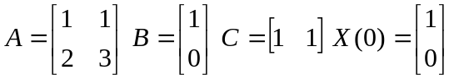
When the input is unit step function.
b) Write a note on observability. [4M]

-- 00 -- 00 --

